
Department of Computer Science

University of Gujrat

Chat Bot for Mental Health

Submitted By:

Anss Abrar | 20021519-053
Ammara Khalid | 20021519-057
Hizar Sajjad | 20021519-068

Supervised By:
Dr. Naveed Anwar Butt

DECLARATION

I certify that project title Chat-Bot for Mental Health is under my supervision with students of Anss Abrar(20021519-053) Ammara Khalid(20021519-57) Hizar Sajjad(20021519 068), Faculty of Computing & Information Technology, University of Gujrat, Pakistan, worked under my supervision.

__________________________________
Dr. Naveed Anwar Butt
Department of Computer Science
Faculty of Computing & Information Technology
University of Gujrat, Punjab, Pakistan.
Email: naveed@uog.edu.pk

FInal Year Project Proposal

Abstract
The proposed "Chatbot for Mental Health" system addresses the escalating need for accessible mental health support, especially in the context of prevalent mental health issues such as depression, anxiety, overthinking, and suicidal thoughts. Grounded in a backdrop of limited access to professional mental health services and persistent stigma, this project aims to develop a versatile chatbot accessible via web and mobile platforms. The system will offer users a confidential and empathetic space to discuss these pressing mental health concerns while providing information, resources, and guidance.
Key modules include the design and development of the chatbot, integration into web or mobile applications, and robust user feedback evaluation. Utilizing the Llama chat pre-trained model, the chatbot will engage users in meaningful conversations, offering tailored support for those dealing with depression, anxiety, overthinking, and suicidal thoughts.
The pros of the system encompass enhanced access, reduced stigma, and scalability, offering hope to individuals struggling with these challenges. However, potential cons may involve privacy concerns and the chatbot's limitations in handling complex issues.
The project's tools and technologies encompass the Llama chat pre-trained model, web or mobile development frameworks, and data security practices. Future directions include continuous improvement of the chatbot's performance, expansion of language capabilities, and integration with other mental health services to provide comprehensive support for those grappling with these pressing issues.
This project promises to leverage technology to provide a lifeline for individuals battling depression, anxiety, overthinking, and suicidal thoughts, promoting well-being, and reducing barriers to access vital support.

Introduction
In an era marked by escalating stressors, lifestyle pressures, and increasing awareness of mental health, the necessity for accessible and immediate support is more apparent than ever. Mental health issues, such as depression, anxiety, overthinking, and suicidal thoughts, affect millions worldwide, yet seeking professional assistance often remains hampered by limited access, the stigma surrounding mental health, and the prohibitive costs of therapy. To address this growing crisis, our project, titled "Chatbot for Mental Health," seeks to innovate by developing a versatile and user-friendly solution.
Grounded in the backdrop of these challenges, our project aims to create a chatbot that offers individuals an empathetic and confidential space to discuss their mental health concerns. We understand that navigating issues like depression and anxiety can be daunting, and for those contemplating suicide, timely support can be lifesaving. This project seeks to bridge the gap, providing accessible, stigma-free, and immediate assistance.
The Chatbot for Mental Health project will involve designing and developing a chatbot powered by natural language processing and machine learning technologies. This chatbot will serve as a scalable and adaptable solution, with the integration decision to be made at a later stage - whether it be within a web application or an Android app, depending on the project's evolving requirements. Through this chatbot, users can seek information, resources, and guidance tailored to their specific mental health concerns. Moreover, user feedback will be meticulously collected and analyzed to enhance the chatbot's capabilities continuously.
By offering an innovative approach to mental health support, this project aspires to reduce the stigma associated with seeking help, increase access to much-needed resources, and ultimately improve the well-being of those facing mental health challenges. The potential of technology to serve as a lifeline for individuals battling depression, anxiety, overthinking, and suicidal thoughts is both promising and transformative. This project endeavors to harness this potential, promising hope and assistance to those in need.

Project Title:
Chatbot for Mental Health

Project Overview statement:
"Chatbot for Mental Health" is our visionary project aimed at providing immediate and accessible mental health support. our chatbot will be accessible through mobile platforms, offering confidential and empathetic conversations to individuals facing emotional challenges such as depression, anxiety, and suicidal thoughts.
We believe in transparency and the urgency of addressing mental health concerns. By leveraging our technical skills, we aim to create a supportive and stigma-free environment for those seeking help. Our vision is to make a meaningful impact on mental health support and contribute to a world where well-being is accessible to all.

Targeted Audience:

- Individuals with Mental Health Concerns: The primary audience for this project includes individuals dealing with various mental health issues such as depression, anxiety, overthinking, and even those with thoughts of self-harm or suicide. These individuals may be seeking immediate support, information, or resources in a confidential and stigma-free environment.
- Support Seekers in Remote or Underserved Areas: People living in remote or underserved areas, where access to mental health professionals is limited, will greatly benefit from the chatbot. It provides a convenient avenue for them to access support and resources.
- Youth and Young Adults: The project acknowledges the increased prevalence of mental health challenges among youth and young adults. These demographics often feel more comfortable seeking help through technology, making them a vital audience.

- Supportive Family and Friends: Family members and friends who are concerned about the mental health of their loved ones may also use the chatbot to gain insights, resources, and guidance on how to support those in need.
- Workplace Wellness Programs: Organizations and businesses can benefit from incorporating the chatbot into their workplace wellness programs, providing employees with a discreet and easily accessible resource for mental health support.
- Healthcare Providers and Professionals: Mental health professionals may also find value in the chatbot as a supplementary tool to provide information and resources to their patients and clients.

Project Goals & Objectives:

Goals:
- Enhance Access to Mental Health Support
- Educate and Increase Awareness on Mental Health Issues
- Reduce Stigma Associated with Mental Health
- User Privacy and Security
- Continuously Improve and Adapt
Objectives:
- Creating an accessible chatbot via web or mobile platforms for immediate mental health support.
- Reducing geographical and socio-economic disparities in access to mental health resources and assistance.
- Offering comprehensive information and resources about mental health topics.
- Promoting mental health awareness and reducing the stigma associated with seeking help.
- Developing a chatbot with the ability to identify and respond to individuals particularly those with suicidal thoughts.
- Collecting and analyzing user feedback, interactions, and performance data.
- Using data-driven insights to continuously enhance the chatbot's capabilities and responsiveness.

Application Architecture:
The "Chatbot for Mental Health" project will adopt a three-tier architecture to ensure modularity, scalability, and maintainability of the system. This architecture is composed of three main layers: the presentation layer, the application logic layer, and the data storage layer.

- Presentation Layer:
This is the user-facing layer where individuals interact with the chatbot. Users can access it through either a web application or a mobile app, which will be developed later. The presentation layer will be responsible for presenting the user interface and collecting user inputs. It will also manage user authentication and registration.

- Application Logic Layer:
The application logic layer houses the core functionality of the chatbot. This is where the chatbot's Llama chat pre-trained model capabilities reside, enabling advanced natural language understanding. It manages chat interactions, interprets user input, and generates appropriate responses based on the insights gleaned from the Llama chat model. The crisis identification and intervention logic, especially for users with suicidal thoughts, is a critical component of this layer, leveraging the strengths of the pre-trained model to handle sensitive situations effectively. Additionally, this layer oversees the collection and storage of chat interactions in the database, ensuring a seamless and confidential user experience rooted in the conversation-based dataset from mental health-related subreddits.

- Data Storage Layer:
This layer is responsible for storing and managing user data and chat interactions.
It includes a database where chatbot conversations, user profiles, and relevant information are stored. The data storage layer ensures data security and reliability and supports data analysis and reporting.

Diagram:

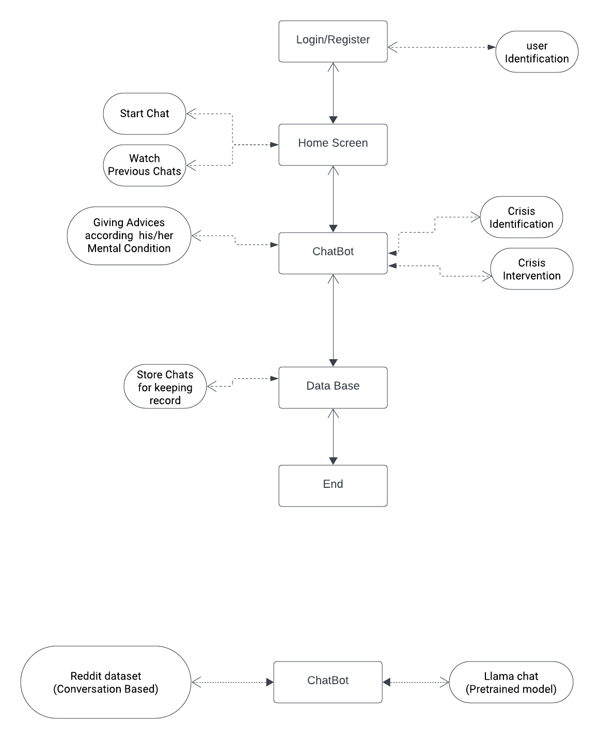

Hardware and Software Specification:
Hardware Specifications:
- User Devices: User with Minimum 2GB of RAM and Free Storage 1-2GB

Software Specifications:
- Development Environment:
Specify the software tools for Flutter app development:
Flutter SDK: The core framework for building mobile apps.
Dart: The programming language used with Flutter.
Integrated Development Environment (IDE): Common choices include Android Studio, Visual Studio Code (VS Code), or IntelliJ IDEA with Flutter and Dart plugins.

Third-party Services and APIs:
Identify any third-party services, APIs, or libraries that we'll integrate into the Flutter app. For example, if we plan to use external services for user authentication or data storage, specify those.

Additional Software Tools:
Depending on the features and functionalities of our app, we may need to specify additional software tools. For example, if we're implementing chat features, mention any chat libraries or services we plan to use.

Estimated Cost:
The cost depends on how much computation power we use to train our model. Essentially, we will subscribe to the Google Colab plan, which costs $9.99 per month. If we require additional computation power, we will consider switching our subscription plan.

Tools and technologies used with reasoning:
Front-End:

Mobile App Development (Flutter):
Reasoning: Flutter is an ideal choice for a cross-platform mobile app. It allows you to develop for both Android and iOS with a single codebase, which is cost-effective and efficient for students. Its rich set of pre-built widgets simplifies UI development.
UI/UX Design (Figma):
Reasoning: Figma is a collaborative and user-friendly design tool, suitable for small teams and students. It allows for real-time collaboration and prototyping, making it a cost-effective choice.

Back-End:

Programming Language (Python):
Reasoning: Python stands out as an optimal choice for chatbot development, particularly when incorporating the Llama pretrained model and leveraging a Reddit conversation-based dataset.

Dataset: Our dataset is like the chatbot's teacher. It's real talks from Reddit about mental health, covering different feelings like sadness and anxiety. We picked conversations from places like MentalHealthCommunity to get a mix of experiences. Everything's private, following the rules, so the chatbot learns to be a good, understanding helper.

Database (Firebase):
Reasoning: Firebase provides a scalable and user-friendly NoSQL database solution, well-suited for various applications, including our project. Its cloud-based nature eliminates the need for server maintenance, making it an excellent choice for seamless integration with our Python-based solution. Firebase offers real-time updates and a straightforward integration process, enhancing the efficiency and scalability of our project.
Version Control (Git):
Reasoning: Git is a standard version control system that is essential for collaborative development. It's free and widely used in the software industry.

Integrated Development Environment (IDE - Visual Studio Code):
Reasoning: Visual Studio Code is a free, lightweight, and highly extensible IDE. It has excellent support for Python and Flutter development, making it a cost-effective choice for students.

Tool Support Needs and Constraints:

Development Platform: The tools are compatible with major development platforms, including macOS, Windows, and Linux.

Target Platform: Flutter allows you to target both Android and iOS platforms.

Programming Language: Python is a versatile language that suits the project's.

Existing Tools: The tools selected are popular and widely used in the industry, ensuring their reliability and support.

Distribution of Development Organization: These tools support distributed teams effectively through version control and collaboration features.

Size of Development Effort: The selected tools are suitable for small to medium-sized development efforts, making them cost-effective for students.

Budget and Time Constraints:
Most of the tools listed are open-source or offer free tiers, which aligns well with budget constraints.

Project milestones and deliverables

Task | Duration (week) | Start Date
Project Initiation | 2 | Week 1
Requirements Gathering | 2 | Week 3
Design and Prototyping | 4 | Week 5
Development | 8 | Week 9
Testing and QA | 4 | Week 17
Data Collection and Training | 4 | Week 21
Integration and Optimization | 4 | Week 25
User Acceptance Testing | 4 | Week 29
Documentation and Report | 4 | Week 33
Project Presentation | 2 | Week 37

Work division among Group members

Hizar Sajjad | Building Chatbot
Anss Abrar | App Development
Ammara Khalid | App Development

